Best of Peru –Cloudforest, Manu-Amazon, Machu Picchu, Colca Canyon
Hundreds of Macaws & Parrots, Andean Condor, Cock of the Rock & more
Unique itinerary with the best Nature & Culture at each area

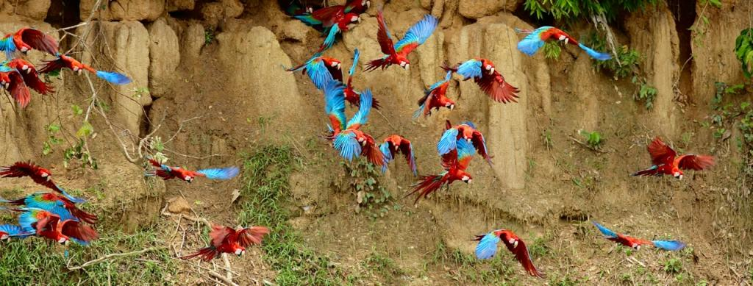

Peru and within that the Manu National Park in the Amazon is surely one of the top destinations for birding & wildlife. If we just make a short list what we had there even on our recce tour, you will know why it is a dream destination for any nature enthusiast: we witnessed an Ocelot catching a Mealy Parrot for breakfast and a Harpy Eagle chasing Red & Green Macaws! All this sitting comfortably in front of a clay-click, sipping coffee. A giant Canopy Tower on a Ceiba tree produced such birds just on that tree like: Magpie-, Green-and-Gold & Paradise Tanager, Plum-throated and Spangled Cotinga, Tui Parakeet, Green & Blue Macaw and many more.
We also had Hoatzin, Horned Screamer, Ladder-tailed Nightjar, Purus Jacamar, Razor-billed Curassow, Swallow-wing, Blue-crowned Trogon, Pale-winged Trumpeter plus loads of Parrots, Parakeets & Macaws everyday.

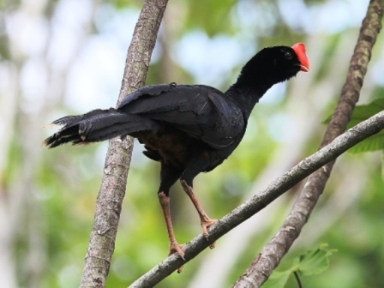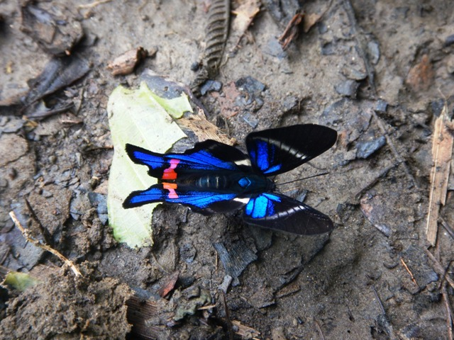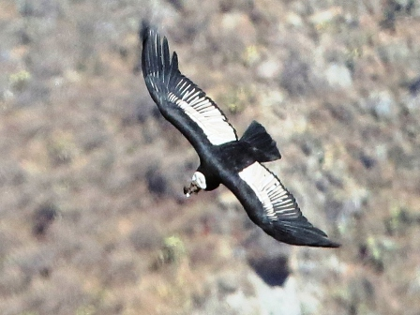

During an extension or post-tour: At the Colca Canyon we almost touched an Andean Condor & a Black-chested Buzzard-Eagle, saw Andean Flamingo and lot of local high elevation species. Add Machu Picchu, Sacred Valley & Cusco with its stunning mix of Nature & Culture, plus tropical butterflies & loads of endemics like Bearded Mountaineer and you will end up with an unforgettable tour for sure!
Please note: all pictures here were made during our last tour (except at day3).

Fact File: - 12 day long tour with 2nights in the cloud forest and 5nights in Manu, Amazon, both world-famous for birding and wildlife watching; - start and finish in Lima, Peru
- using at each areas great lodges with superb on site birding & wildlife watching
- daily boat trips to number one clay-licks or canopy towers or oxbow lakes
Extension possibility:
- 4days with Machu Picchu and Colca Canyon

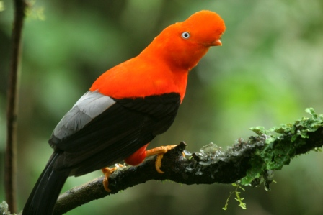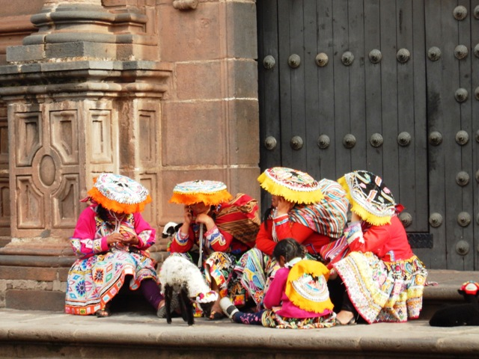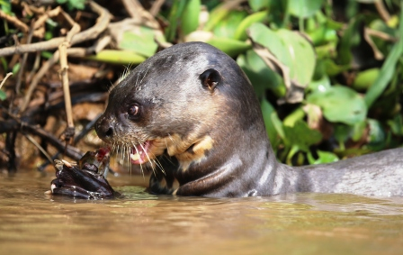

Highlights
- Peruvian Cock of the Rock, Horned Screamer, Ladder-tailed Nightjar, Purus Jacamar, Razor-billed Curassow, Hoatzin, Swallow-wing, Pale-winged Trumpeter plus loads of Parrots, Parakeets & Macaws everyday, even Harpy Eagle is possible!
- any of the 5 cat species, Giant River Otters, monkeys & other mammals,
- amazing landscape, days without roads & settlements at Manu, Amazon
- wide variety of birds, mammals, reptiles, butterflies and habitats

Highlights during extension:
- scenic luxury train trip to Aguas Calientes
- Machu Picchu Inca ruins & some great local birds
- Colca Canyon with Andean Condor, plus plenty of high elevation species on the way
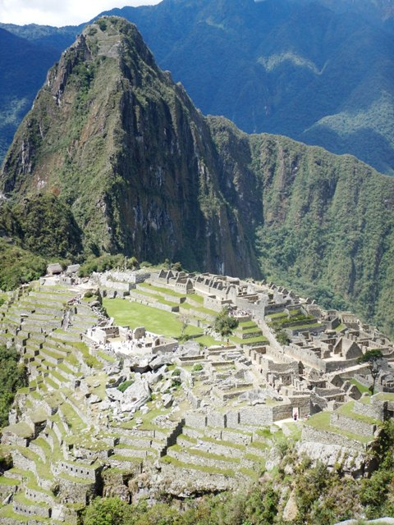
Accommodation
1 night Lima
2 nights Cusco, 1 at the beginning, 1 at the end
2 nights Cock of the Rock Lodge
5 nights in Manu Reserve
1 overnight flight home

Accommodation during extension
1 night Aguas Calientes
1 night Cusco
1 night Chimay
1 night Cusco

Dates
-Tuesday 28thMarch - Wednesday 8thApril,2017, 12days
-extension possibility to Machu Picchu & Colca Canyon

Our price includes
- all land travel within the country from Cusco as noted in the itinerary;
- all accommodation based on shared rooms, single rooms for extra charge;
- services of the leader(s); - trip materials
- 3 meals per day, generally full breakfast, lunch & dinner (usually 3 courses);
Activity level & other info
Easy to moderate walks; some areas are hot and humid, at high elevation can be cold; rain is possible even during dry season; sudden weather changes possible in the hilly area
Altitude sickness can be an issue
Travel to Manu involves a long transfer day driving through the hills, crossing some rivers, perhaps 4x4 drive & boat trip
To reach Colca Canyon involves a long mountain drive, but with several great birding stops
Daily outings on small motorboats to search wildlife morning & afternoon

